SIMATS ENGINEERING
CO2_ASSESSMENT TOOL3_ Dry Run Evaluation

COURSE NAME: Artificial Intelligence COURSE CODE: CSA1709

Register Number | 192212301
Name | KAPPALA ABHISHEK DASS

COURSE OUTCOME COVERED

CO2: Experiment search and game-solving techniques such as Greedy Search, A*, CSP, Minimax, and Alpha-Beta pruning with heuristic functions for solving complex AI problems efficiently. (BL3)

Assessment Tool Weightage: 20%

QUESTIONS: 5 Total Marks:50

Q1. Consider a suitable state-space graph (with heuristic values h(n) assigned to each node) of your choice for a given problem. Perform a dry run of Greedy Best-First Search from the start node to the goal node. Clearly show the frontier/open list, the node selected for expansion at each step, and the final path obtained.
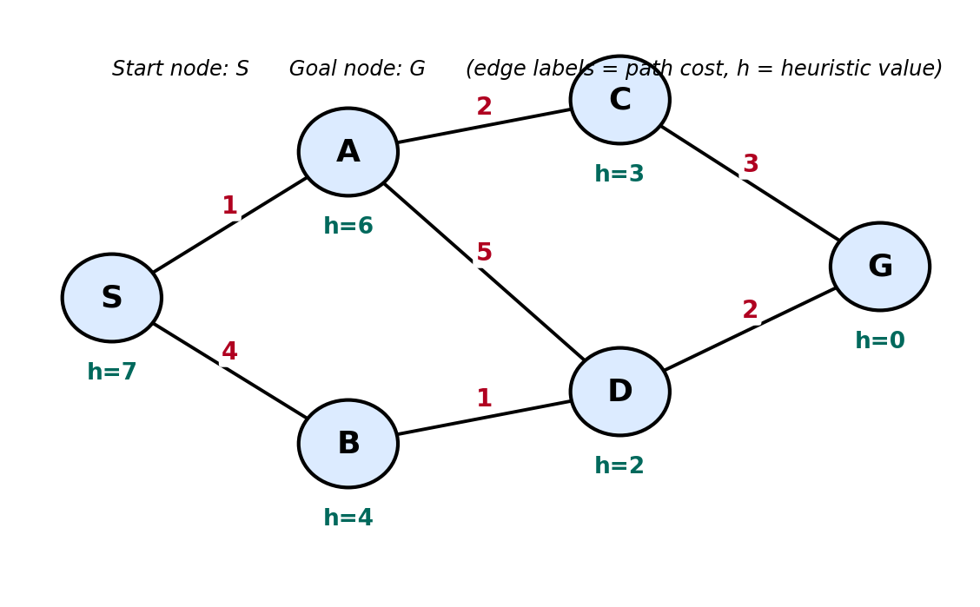

Q2. For a suitable weighted state-space graph (with edge costs and heuristic values h(n)) of your choice, perform a dry run of A* Search from the start node to the goal node. Show the g(n), h(n) and f(n) values computed at every step, the order in which nodes are expanded, and the final optimal path along with its total cost.


Q3. Formulate a given Constraint Satisfaction Problem (e.g., Map Colouring / N-Queens) by clearly stating the variables, their domains, and the constraints involved. Perform a dry run of the Backtracking Search algorithm, showing each variable assignment, every constraint check, and any backtracking steps, until a complete solution (or failure) is reached.
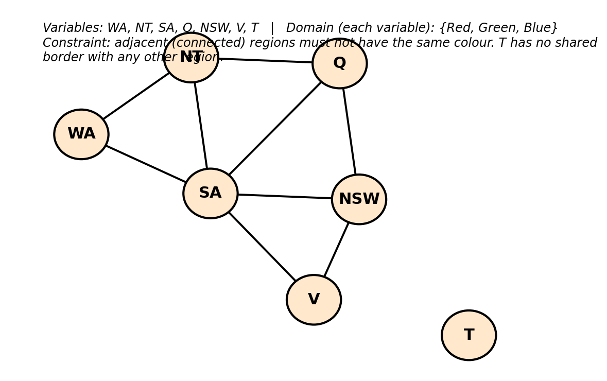

Q4. For a given two-player game tree of your choice (at least 3 levels deep), perform a dry run of the Minimax algorithm. Show the utility values at the leaf/terminal nodes and the backed-up values computed at every internal node, and state the best move for the MAX player with justification.
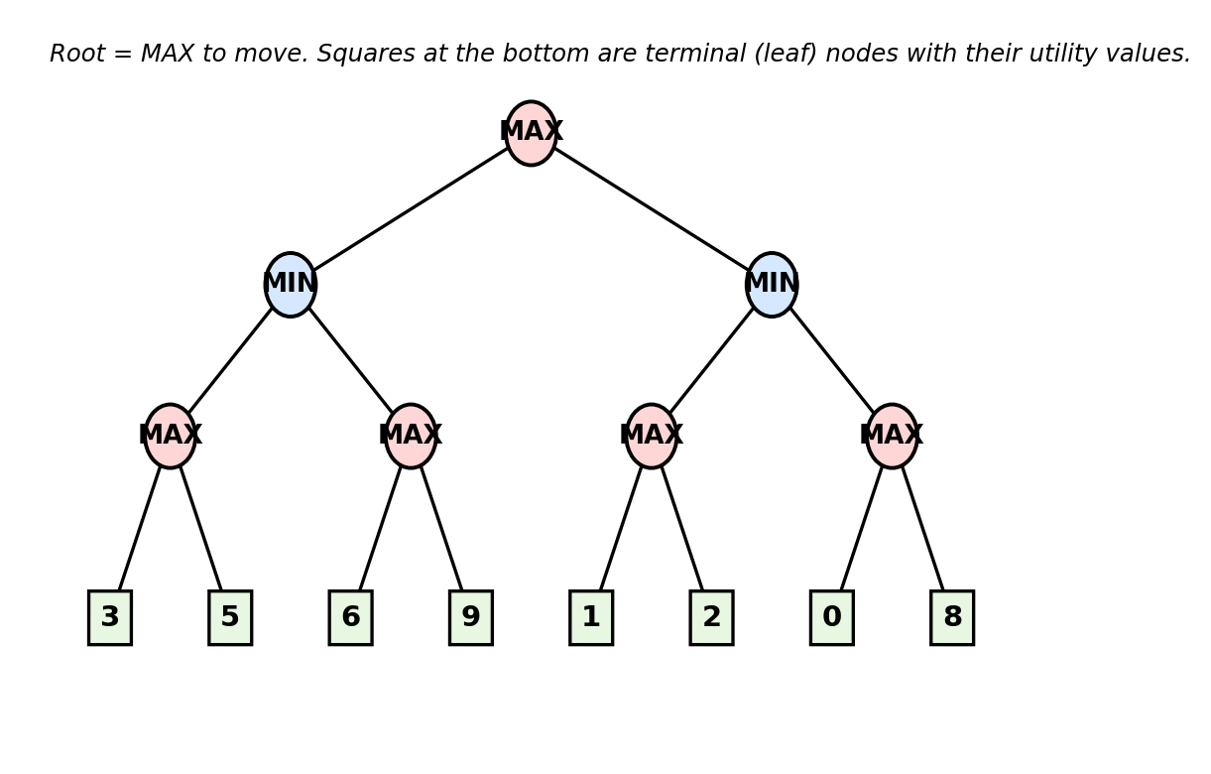

Q5. Using the same (or a different) game tree from Q4, perform a dry run of the Minimax algorithm with Alpha-Beta Pruning. Show the α and β values maintained at each node during the traversal, clearly indicate which branches get pruned and why, and state the final best move obtained.


Code of Conduct:

I K.ABHISHEK DASS / 192212301 certify that this submission is my original work and that I have adhered to the guidelines specified for this assessment.
I understand that any violation of academic integrity rules will result in disciplinary action.

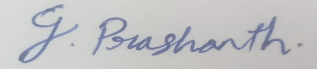
Signature of the student:

Dry Run Evaluation

RUBRICS FOR CALCULATION

Criteria | Level 4 – Exemplary | Level 3 – Proficient | Level 2 – Developing | Level 1 – Beginning | Max Marks
Problem Formulation & Setup (states/nodes, heuristic values or CSP variables, domains and constraints correctly identified) | Accurately identifies all required elements (states, heuristics/costs, or variables/domains/constraints) with clear, correct notation. | Identifies most required elements correctly, with only minor omissions or notational errors that do not affect the dry run. | Identifies some required elements; noticeable errors or missing components affect the later steps. | Little or no correct problem formulation; required elements are largely missing or incorrect. | 10
Correct Application of Algorithm Procedure (expansion order, backtracking, or pruning as per the standard method) | Follows the exact algorithmic procedure at every step with no deviation from the standard method. | Follows the procedure correctly for most steps, with only one or two minor deviations that do not change the outcome. | Several steps deviate from the correct procedure, though the overall approach is recognisable. | Algorithm steps are largely incorrect, or the procedure is not followed. | 10
Accuracy of Computations (g(n), h(n), f(n) values, minimax backed-up values, or α–β updates) | All computed values are accurate and consistent throughout the dry run. | Minor calculation errors are present but do not significantly affect the final outcome. | Multiple calculation errors are present that affect the correctness of intermediate steps. | Calculations are mostly incorrect or missing. | 10
Correctness of Final Outcome (final path, CSP solution, or best move obtained) | Final result is completely correct and matches the expected optimal outcome. | Final result is mostly correct, with only a minor deviation from the optimal outcome. | Final result is only partially correct. | Final result is incorrect or not obtained. | 10
Clarity of Presentation & Justification (trace tables/trees/diagrams, explanation of each step) | Dry run is presented clearly using well-organised tables/trees/diagrams, with every step explained and justified. | Dry run is reasonably clear and mostly organised, with minor gaps in explanation. | Dry run presentation is unclear or poorly organised, with limited justification. | Dry run is disorganised or illegible, with little to no justification. | 10
 |  |  |  | Total | 50

Answers for above questions

1. Dry Run of Greedy Best-First Search
Start Node: S
Goal Node: G
Step 1: Heuristic Values
Node Heuristic h(n)
S 7
A 6
B 4
C 3
D 2
G 0

Greedy Best-First Search Evaluation Function:
f(n)=h(n)
The algorithm always expands the node with the smallest heuristic value.
Dry Run
Initial State
Open List (Frontier):
[S(7)]
Closed List:
[]
Selected Node:
S
Step 1: Expand S
Children of S:
A (h=6)
B (h=4)
Open List:
[B(4), A(6)]
Closed List:
[S]
Selected Node:
B
Step 2: Expand B
Child of B:
D (h=2)
Open List:
[D(2), A(6)]
Closed List:
[S, B]
Selected Node:
D
Step 3: Expand D
Children of D:
G (h=0)
A (already in Open List)
Open List:
[G(0), A(6)]
Closed List:
[S, B, D]
Selected Node:
G
Step 4: Expand G
The goal node is reached.
Search Stops.
Order of Node Expansion
S → B → D → G
Final Path Obtained
S → B → D → G
Path Cost
Using the edge costs:
S → B = 4
B → D = 1
D → G = 2
Total Cost
4+1+2=7

2. Dry Run of A* Search
Start Node: S
Goal Node: G
A* Evaluation Function
f(n)=g(n)+h(n)
Where:
g(n) = Cost from the start node to node n
h(n) = Heuristic estimate to the goal
f(n) = Total estimated cost
Heuristic Values
Node h(n)
S 7
A 6
B 4
C 3
D 2
G 0
Step 1: Start at S
g(S)=0,h(S)=7,f(S)=0+7=7
Open List
Node g h f
S 0 7 7
Expand: S
Step 2: Expand S
Successors:
A
g=0+1=1
h=6
f=1+6=7
B
g=0+4=4
h=4
f=4+4=8
Open List
Node g h f
A 1 6 7
B 4 4 8
Expand: A (lowest f)
Step 3: Expand A
Successors:
C
g=1+2=3
h=3
f=3+3=6
D
g=1+5=6
h=2
f=6+2=8
Open List
Node g h f
C 3 3 6
B 4 4 8
D 6 2 8
Expand: C
Step 4: Expand C
Successor:
G
g=3+3=6
h=0
f=6+0=6
Open List
Node g h f
G 6 0 6
B 4 4 8
D 6 2 8
Expand: G
Since G is the goal node, the search stops.
Order of Node Expansion
S → A → C → G
Final Optimal Path
S → A → C → G
Total Path Cost
Using edge costs:
S → A = 1
A → C = 2
C → G = 3
Total Cost=1+2+3=6

3. Constraint Satisfaction Problem (Map Colouring) – Backtracking Search Dry Run
Step 1: Formulate the CSP
Variables
The variables represent the Australian states and territories:
WA (Western Australia)
NT (Northern Territory)
SA (South Australia)
Q (Queensland)
NSW (New South Wales)
V (Victoria)
T (Tasmania)
Domains
Each variable can take one of the following colours:
{Red, Green, Blue}
Constraints
Adjacent regions must not have the same colour.
The adjacency constraints are:
WA != NT
WA != SA
NT != SA
NT != Q
SA != Q
SA != NSW
SA != V
Q != NSW
NSW != V
Step 2: Dry Run of Backtracking Search
Variable Order
WA → NT → SA → Q → NSW → V → T
Step 1: Assign WA
Try Red
No constraint violated.
Assignment
WA = Red
Step 2: Assign NT
Try Red
Constraint violated
WA = NT = Red
Backtrack and try another colour.
Try Green
Valid
Assignment
WA = Red
NT = Green
Step 3: Assign SA
Try Red
Violates
WA = SA = Red
Try Green
Violates
NT = SA = Green
Try Blue
Valid
Assignment
WA = Red
NT = Green
SA = Blue
Step 4: Assign Q
Try Red
Valid
Q is adjacent to NT and SA only.
NT = Green
SA = Blue
No conflict.
Assignment
WA = Red
NT = Green
SA = Blue
Q = Red
Step 5: Assign NSW
Try Red
Conflict
Q = NSW = Red
Try Green
Valid
Adjacent states:
SA = Blue
Q = Red
No conflict.
Assignment
WA = Red
NT = Green
SA = Blue
Q = Red
NSW = Green
Step 6: Assign V
Try Red
Valid
Adjacent states:
SA = Blue
NSW = Green
No conflict.
Assignment
WA = Red
NT = Green
SA = Blue
Q = Red
NSW = Green
V = Red
Step 7: Assign T
Tasmania has no neighboring states.
Try Red
Valid
Assignment
WA = Red
NT = Green
SA = Blue
Q = Red
NSW = Green
V = Red
T = Red
Final Solution
Variable Colour
WA Red
NT Green
SA Blue
Q Red
NSW Green
V Red
T Red
Constraint Checking
WA != NT
WA != SA
NT != SA
NT != Q
SA != Q
SA != NSW
SA != V
Q != NSW
NSW != V
All constraints are satisfied.
Backtracking Performed
Only two backtracking steps were required:
NT: Red → Green
SA: Red → Green → Blue

4. Dry Run of the Minimax Algorithm
Step 1: Game Tree
Root Node: MAX
Level 1: MIN
Level 2: MAX
Level 3: Terminal (Leaf) Nodes
The terminal node utility values are:
Left Subtree:
(3, 5)
(6, 9)
Right Subtree:
(1, 2)
(0, 8)
Step 2: Evaluate Leaf Nodes
The utility values are already given.
3 5 6 9 1 2 0 8
Step 3: Evaluate MAX Nodes (Bottom-Up)
MAX Node 1
Children:
3, 5
MAX chooses the larger value.
max(3,5)=5
Value backed up:
MAX = 5
MAX Node 2
Children:
6, 9
max(6,9)=9
Value backed up:
MAX = 9
MAX Node 3
Children:
1, 2
max(1,2)=2
Value backed up:
MAX = 2
MAX Node 4
Children:
0, 8
max(0,8)=8
Value backed up:
MAX = 8
Step 4: Evaluate MIN Nodes
Left MIN Node
Children:
5, 9
MIN chooses the smaller value.
min(5,9)=5
Value backed up:
MIN = 5
Right MIN Node
Children:
2, 8
min(2,8)=2
Value backed up:
MIN = 2
Step 5: Evaluate Root MAX Node
Children:
5, 2
MAX chooses the larger value.
max(5,2)=5
Therefore,
Root Value = 5
Compute MAX values:
MAX(3,5) = 5
MAX(6,9) = 9
MAX(1,2) = 2
MAX(0,8) = 8
Compute MIN values:
MIN(5,9) = 5
MIN(2,8) = 2
Compute root MAX:
MAX(5,2) = 5
Best Move for MAX Player
The root MAX player compares the two available moves:
Left subtree → Value = 5
Right subtree → Value = 2
Since 5 > 2, the MAX player selects the left subtree.

5. Dry Run of Minimax with X-Y Pruning
Initial Values
Root (MAX): X =−Infinity , Y =+Infinity
The tree is evaluated from left to right.
Step 1: Evaluate Left MIN Node
First MAX Node
Leaf values: 3, 5
max(3,5) = 5
MIN updates:
X = −Infinity
Y = min(+Infinity ,5) = 5
Second MAX Node
Receives:
X = −Infinity
Y = 5
Evaluate first leaf:
Value = 6
MAX updates:
X = max(−Infinity ,6) = 6
Since
X≥Y
6≥5
Y-cutoff occurs.
The second leaf 9 is pruned because it cannot affect the MIN node's final decision.
Left MIN returns:
min(5,6)=5
Step 2: Update Root MAX
Current value at Root:
X = max(−Infinity ,5) = 5
Y = +Infinity
Step 3: Evaluate Right MIN Node
Receives:
X = 5
Y = +Infinity
Third MAX Node
Leaf values:
1
2
MAX chooses:
max(1,2)=2
MIN updates:
Y=min(+Infinity ,2)=2
Now
Y≤X
2≤5
X-cutoff occurs.
Therefore, the entire fourth MAX subtree (0, 8) is pruned because it cannot improve the Root MAX value.
Right MIN returns 2.
Step 4: Evaluate Root MAX
Root compares:
Left MIN = 5
Right MIN = 2
max(5,2)=5
(X) and (Y) Values
Step Node X Y Action
1 Root MAX −Infinity +Infinity Start
2 Left MIN −Infinity 5 After first MAX
3 Second MAX 6 5 Y-cutoff, prune 9
4 Root MAX 5 +Infinity Update X
5 Right MIN 5 2 X-cutoff
6 Fourth MAX Pruned Pruned Entire subtree skipped
Pruned Branches
Leaf node 9 was pruned because:
X=6≥Y=5
Entire subtree (0, 8) was pruned because:
Y=2≤X=5
These branches cannot change the final Minimax decision.
Final Best Move
The Root MAX player compares:
Left subtree = 5
Right subtree = 2
Since
5>2
the MAX player chooses the left subtree.

